Memory one strategies

One Mutation at a time: N(0,0.02)

Closest to one of the 5.

Green – TFT

Blue : AllD

Ornage: Random

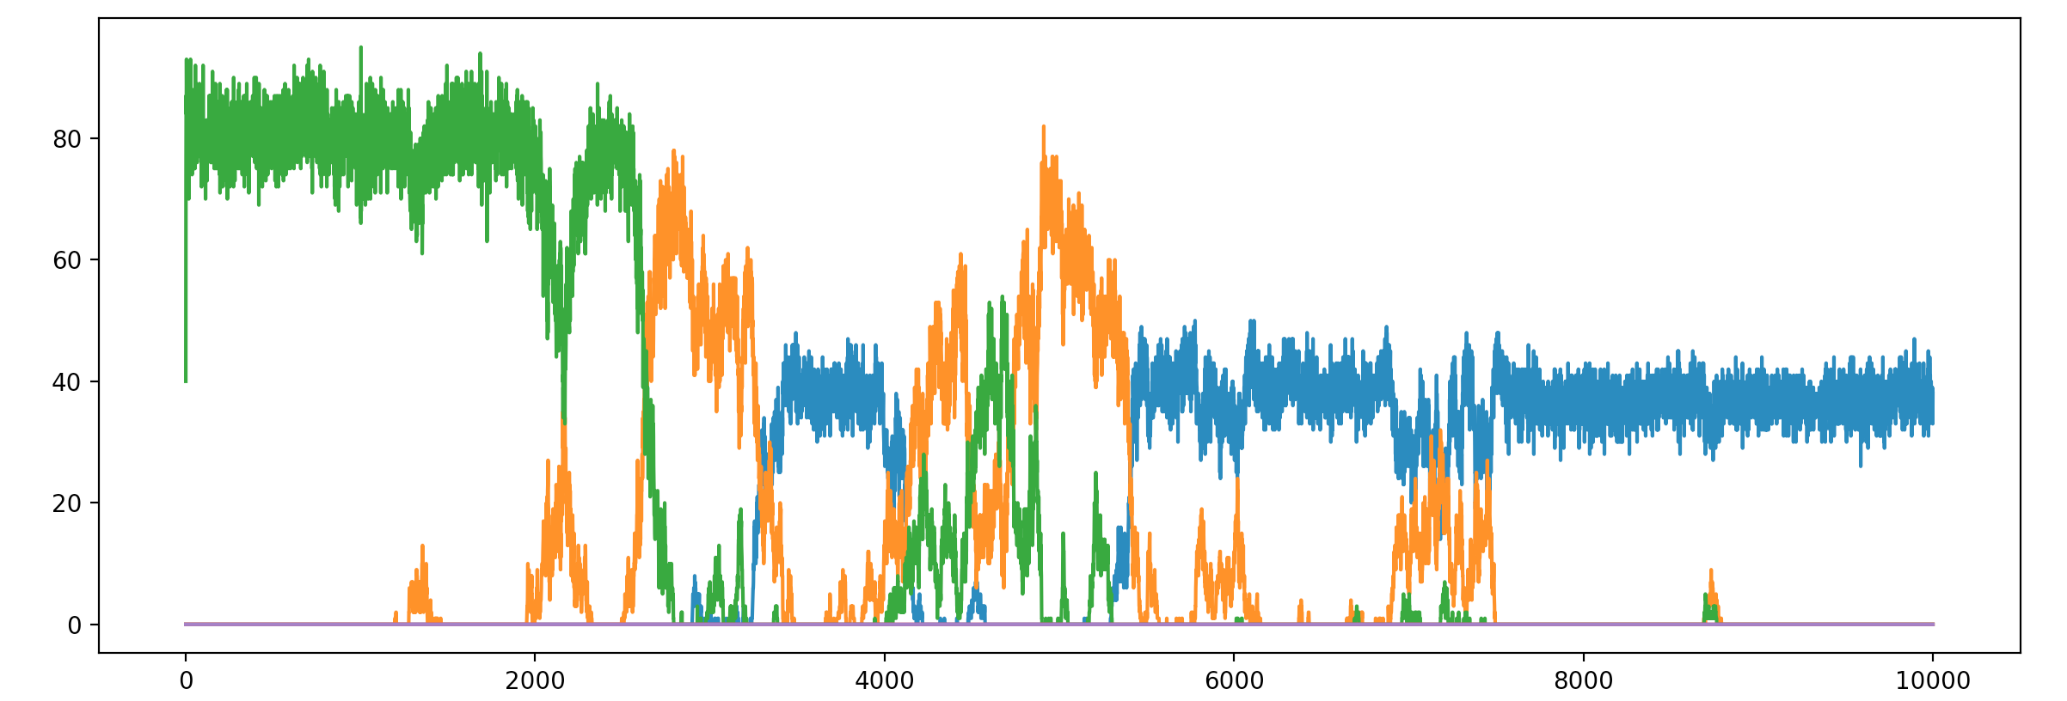

Green – 0.8 < c+d <1.2 : ~TFT

Blue : 0< c+d < 0.4 : ~ALLD

Purple: 1.6<c+d<2: ~ALLC

Orange : 0.4 <c+d<0.8

One Mutation at a time: N(0,0.02)

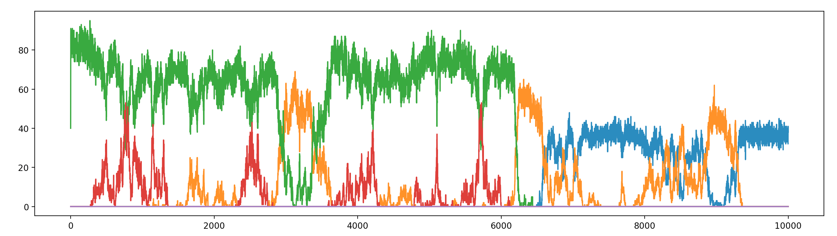

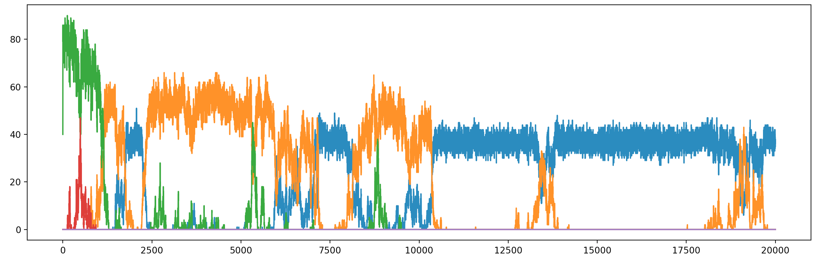 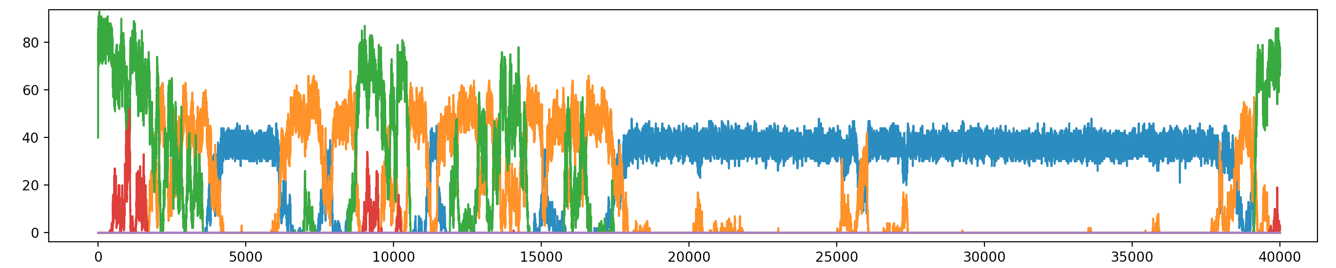

One Mutation at a time: N(0,0.1)

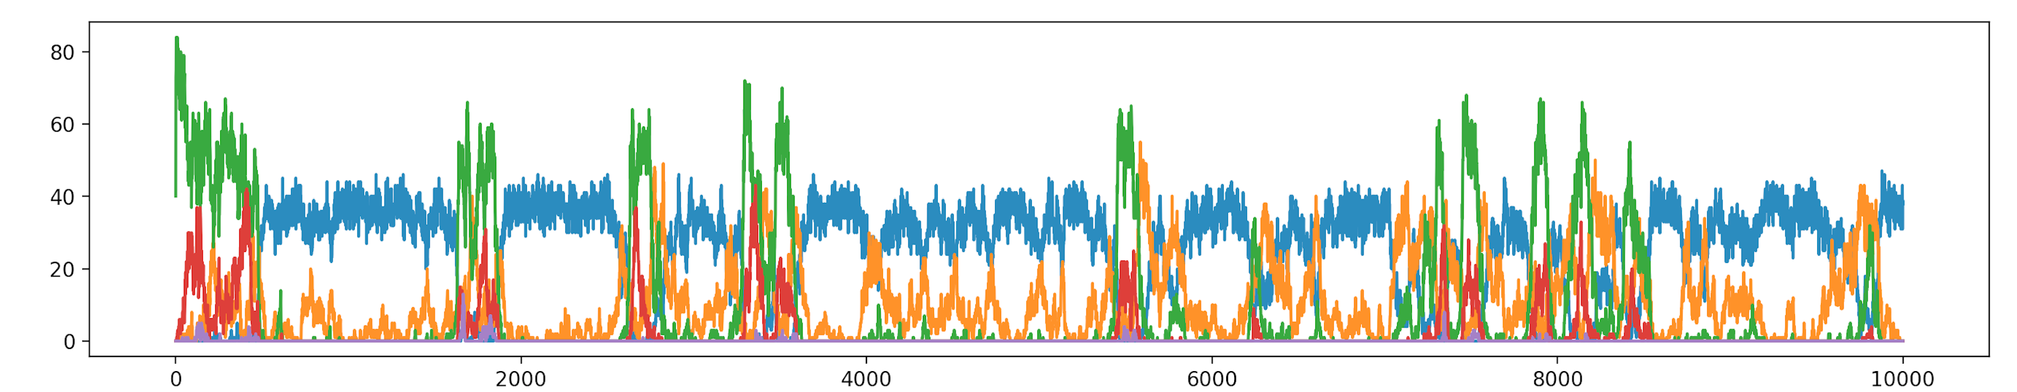

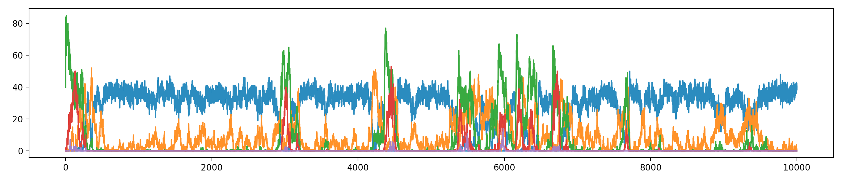

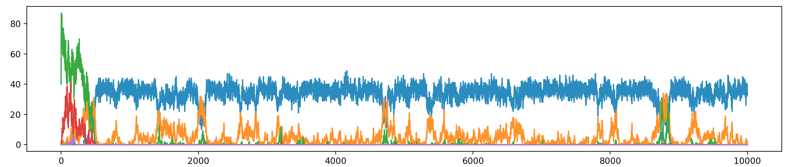

Many Mutation at a time: N(0,0.1)

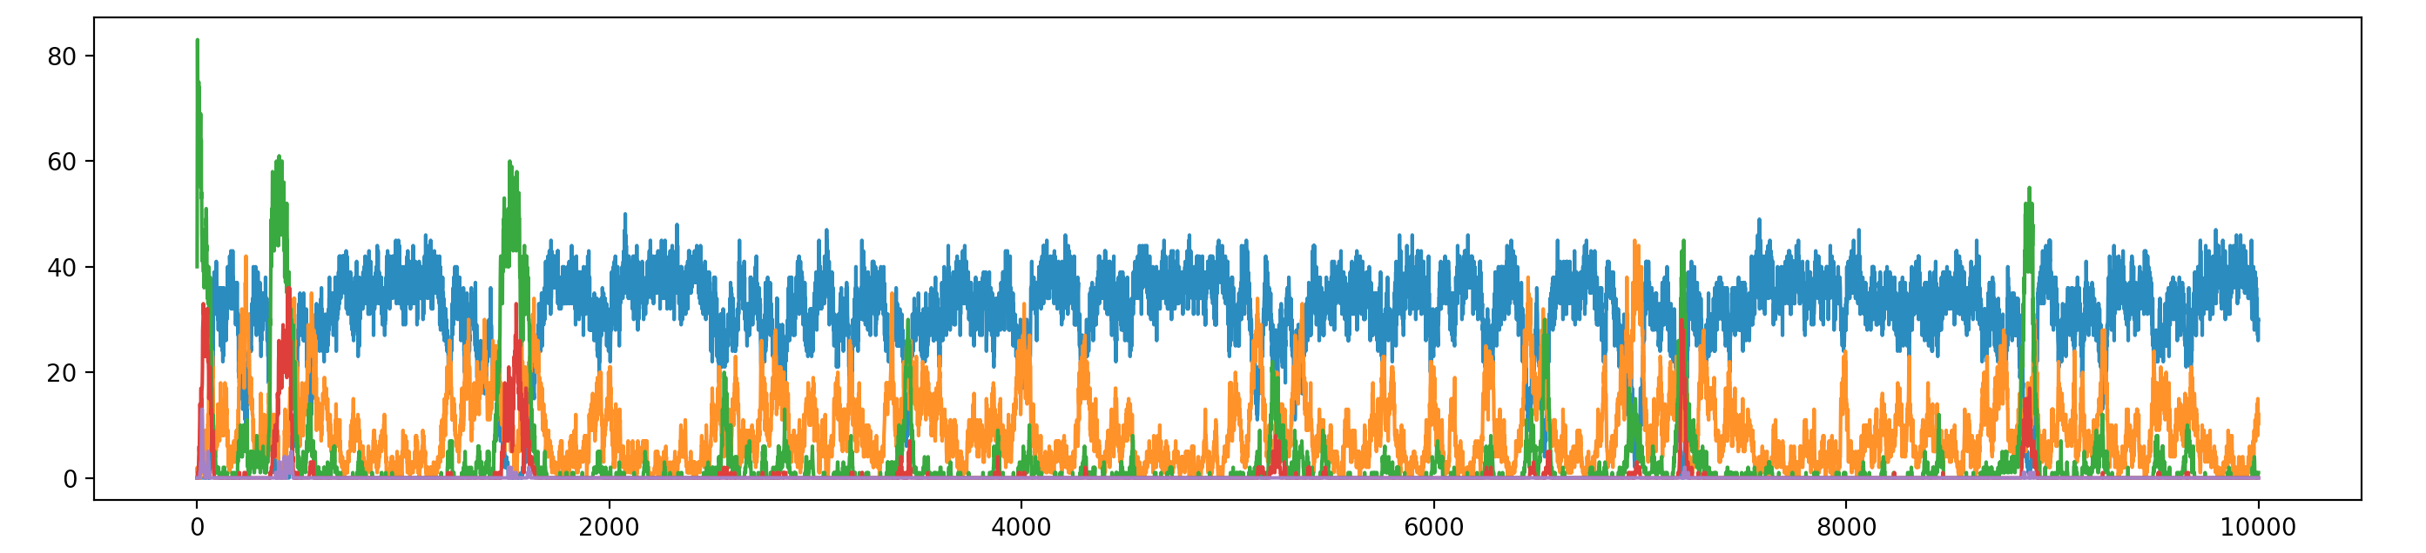 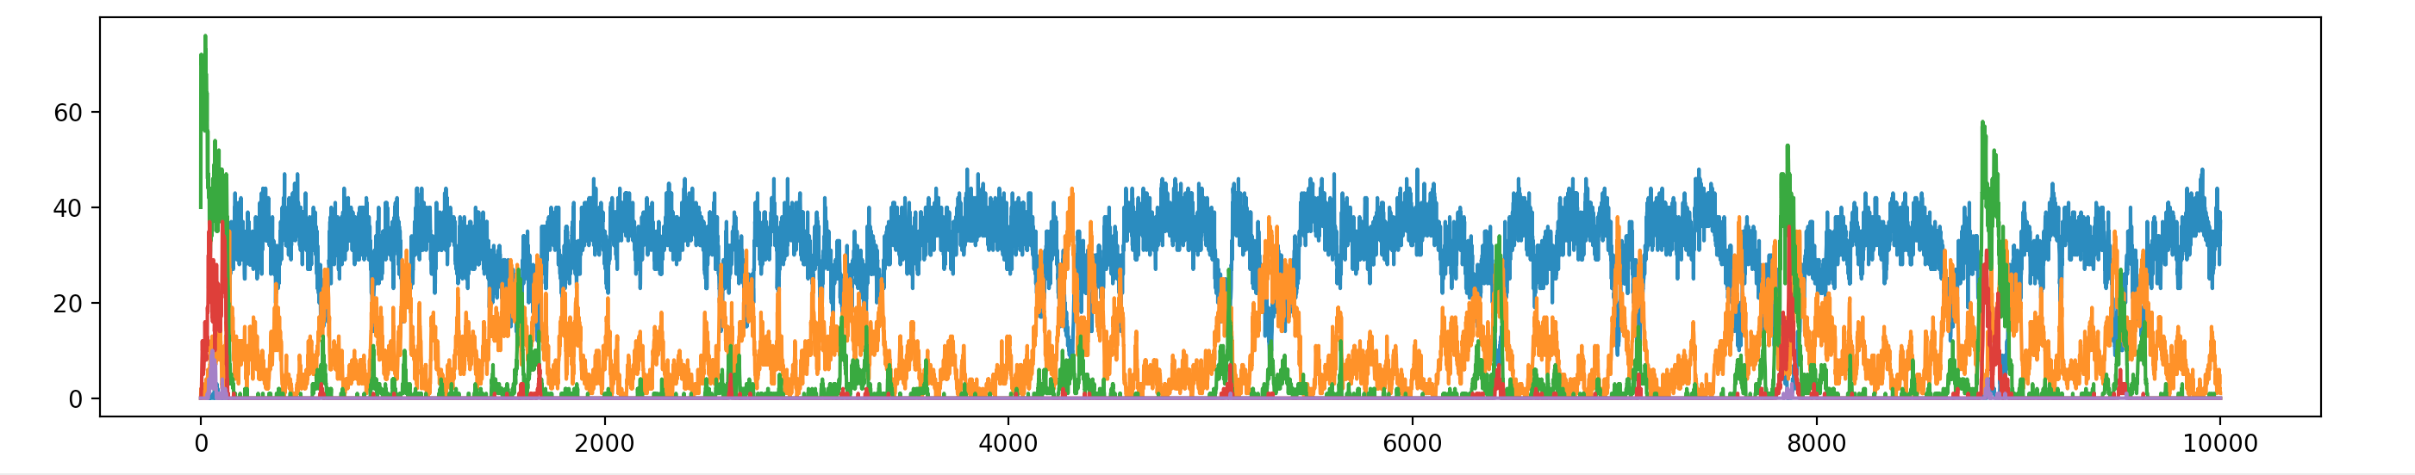

One Mutation at a time: N(0,0.2)

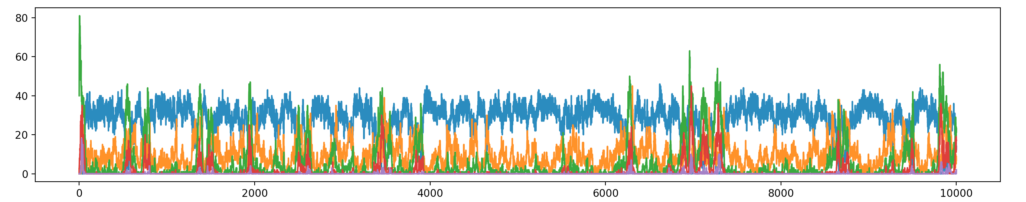

One Mutation at a time: N(0,0.5)

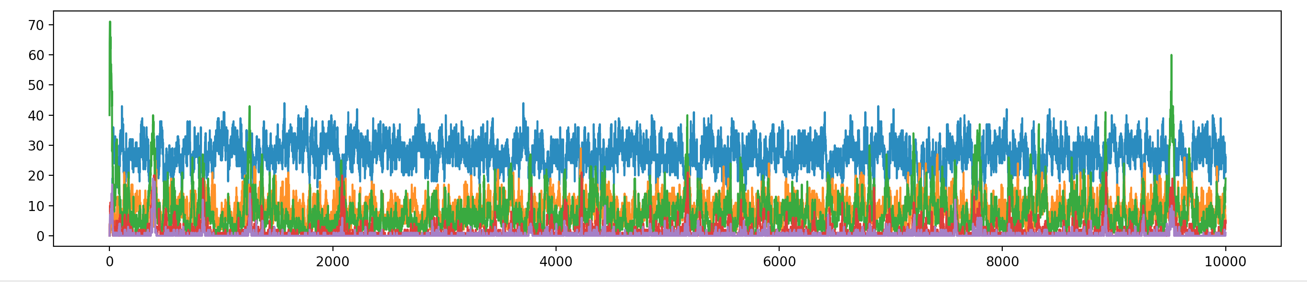

Memory 2 strategies

**Does not make a lot of sense but since you know your opponent better. You should technically do better. But Most will be closeset to random.**

4 Strategy Parmeters #(How to respond to given last 2 moves of opponent – [cc,cd,dc,dd])

All mutation at a time: N(0,0.1)

Orange: Closest to Random (0.5,0.5,0.5,0.5)

Blue: Closest to AllD (0,0,0,0)

Green : Closeset to TFT(1,0,1,0)

Red: Closest to (0,1,0,1)

Purple: Closest to AllC(1,1,1,1)

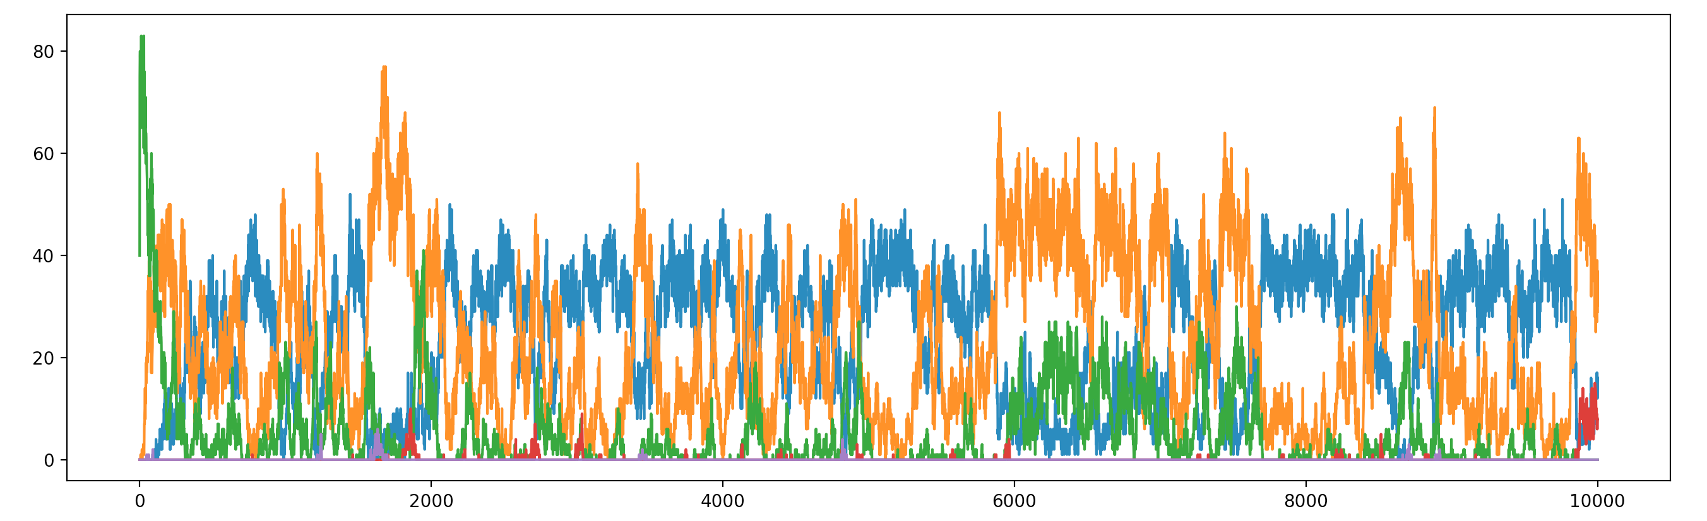 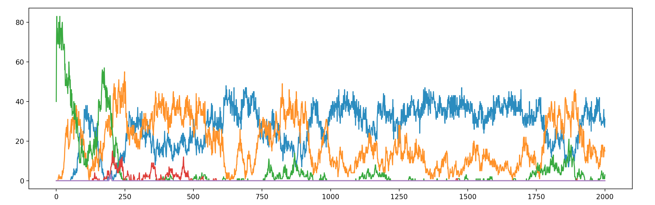 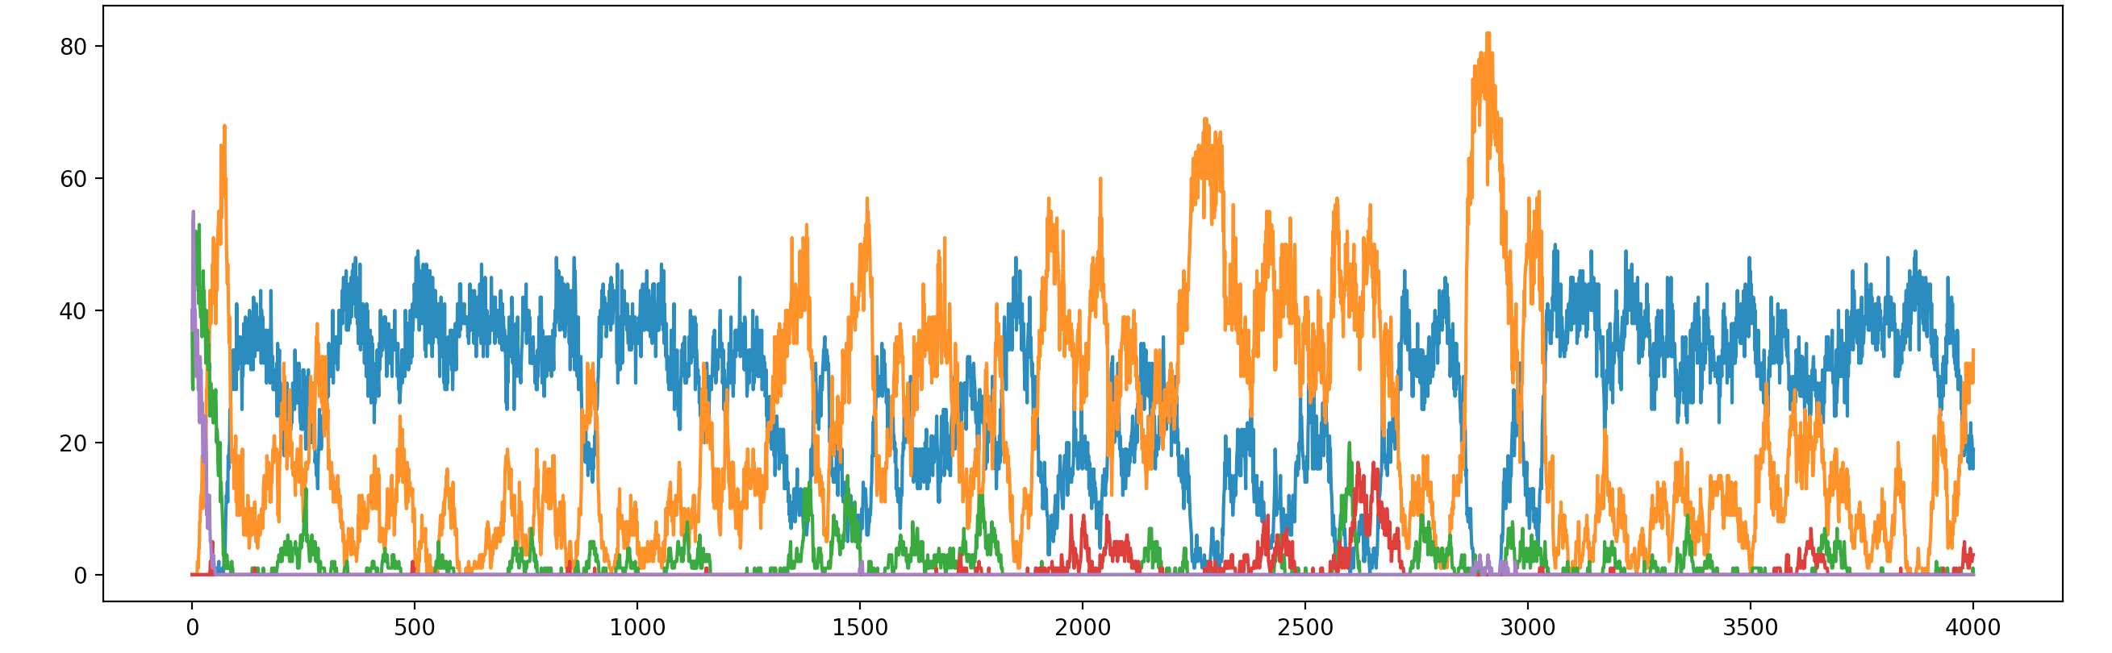

4 Strategy Parmeters #(How to respond to given last 2 moves of opponent – [cc,cd,dc,dd])

All mutation at a time: N(0,0.1)

Orange: Closest to TFTT(1,1,1,0)

Blue: Closest to AllD (0,0,0,0)

Green : Closeset to TFT(1,0,1,0)

Red: Closest to TTFT(1,0,0,0)

Purple: Closest to AllC(1,1,1,1)

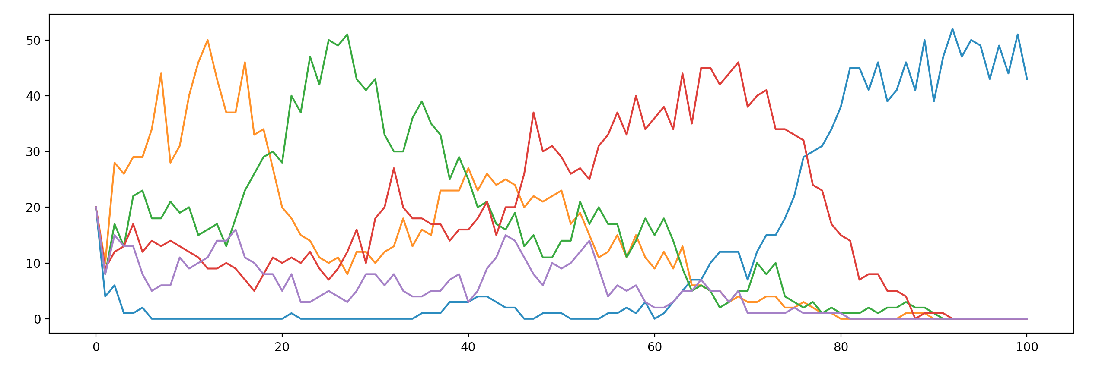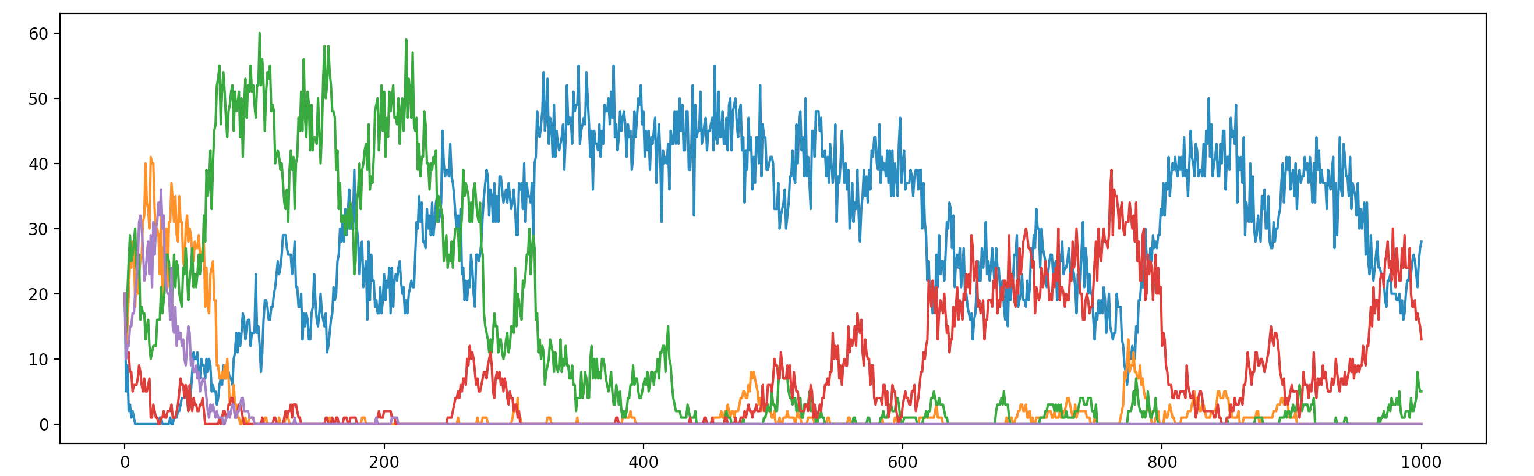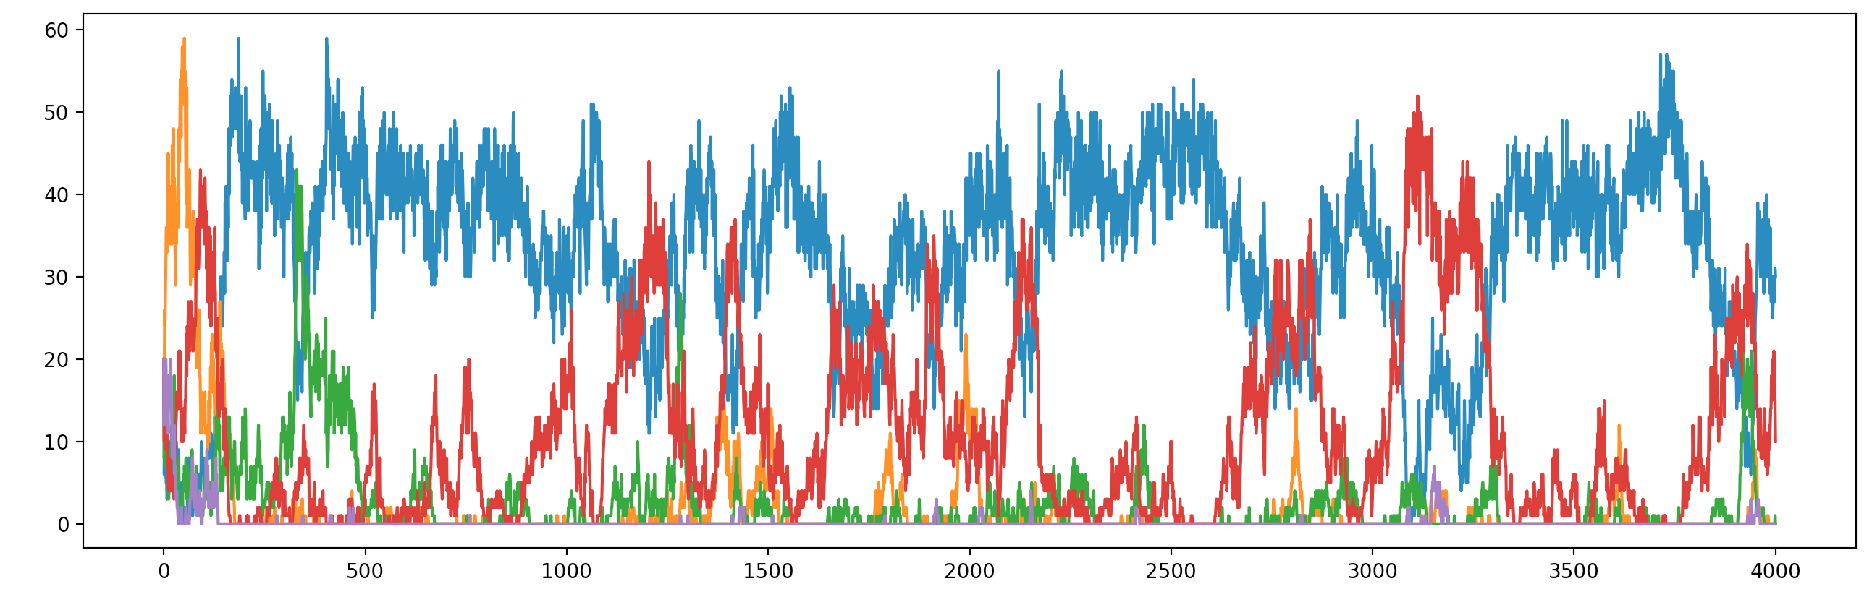

4 Strategy Parmeters #(How to respond to given my last and op last– [cc,cd,dc,dd])

All mutation at a time: N(0,0.1)

Orange: Closest to (1,0,1,1)

Blue: Closest to AllD (0,0,0,0)

Green : Closeset to TFT(1,0,1,0)

Red: Closest to (1,0,0,1)

Purple: Closest to AllC(1,1,1,1)

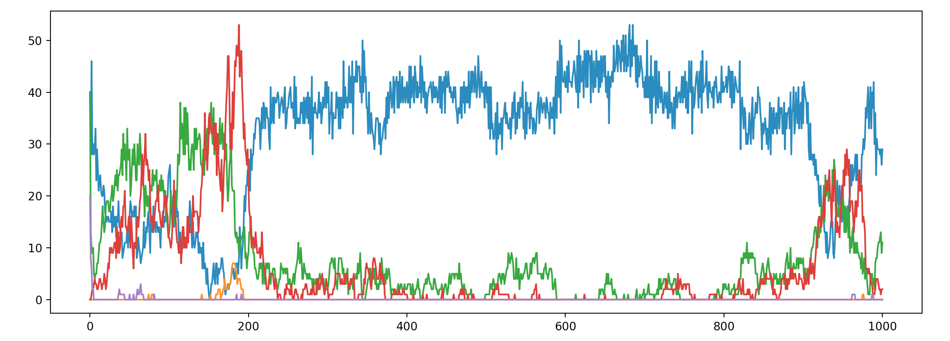 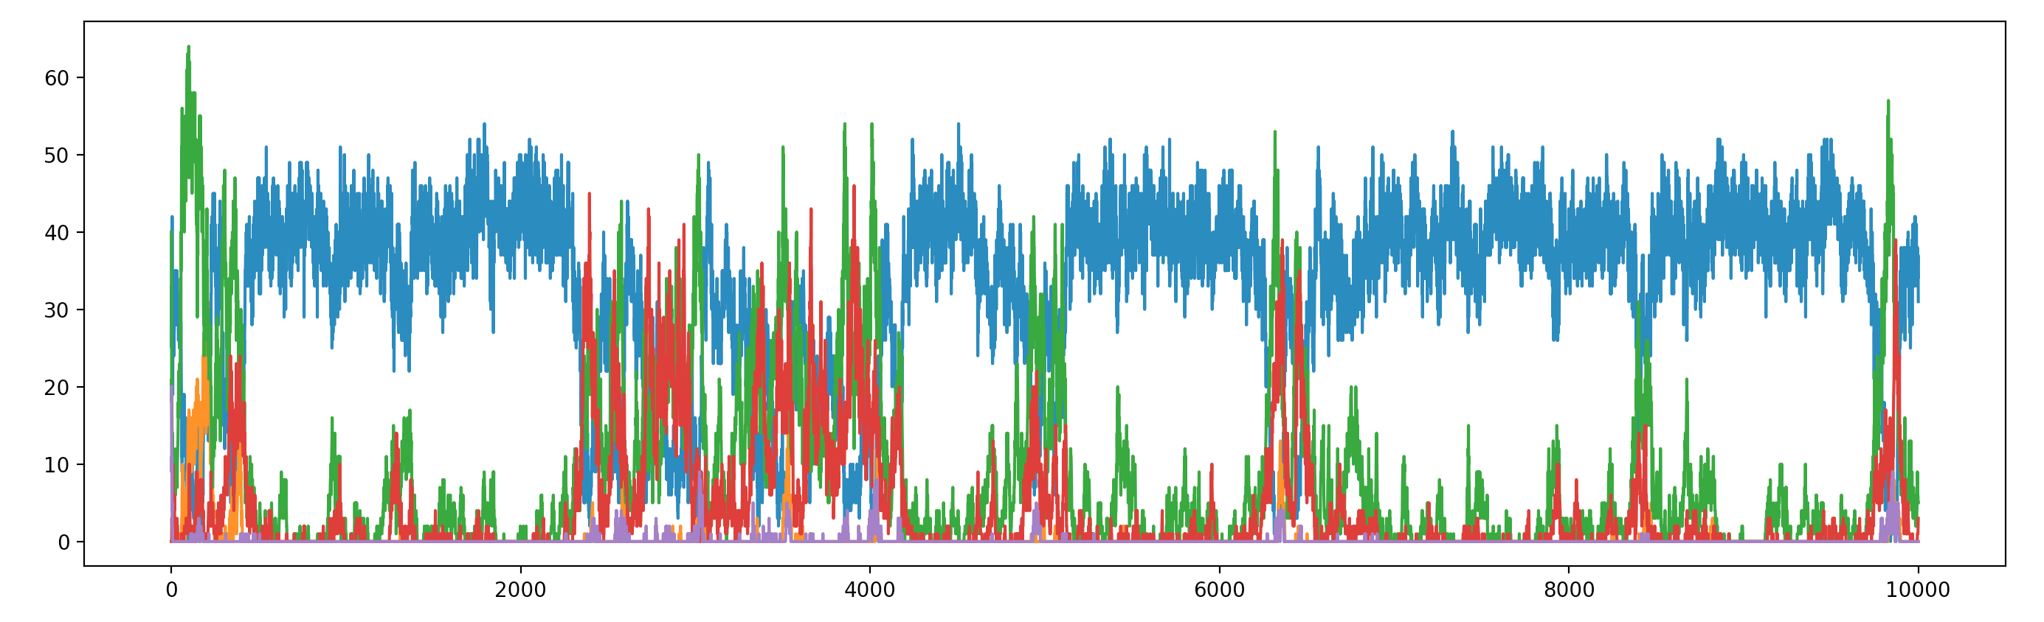

4 Strategy Parmeters #(How to respond to given my last and op last – [cc,cd,dc,dd])

All mutation at a time: N(0,0.1)

All Closest

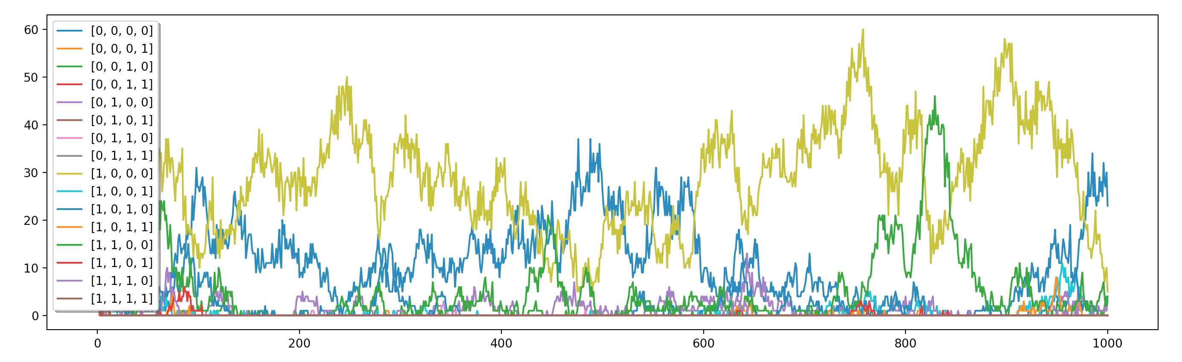

23 0 3 0 3 0 0 0 5 0 0 0 4 0 0 0

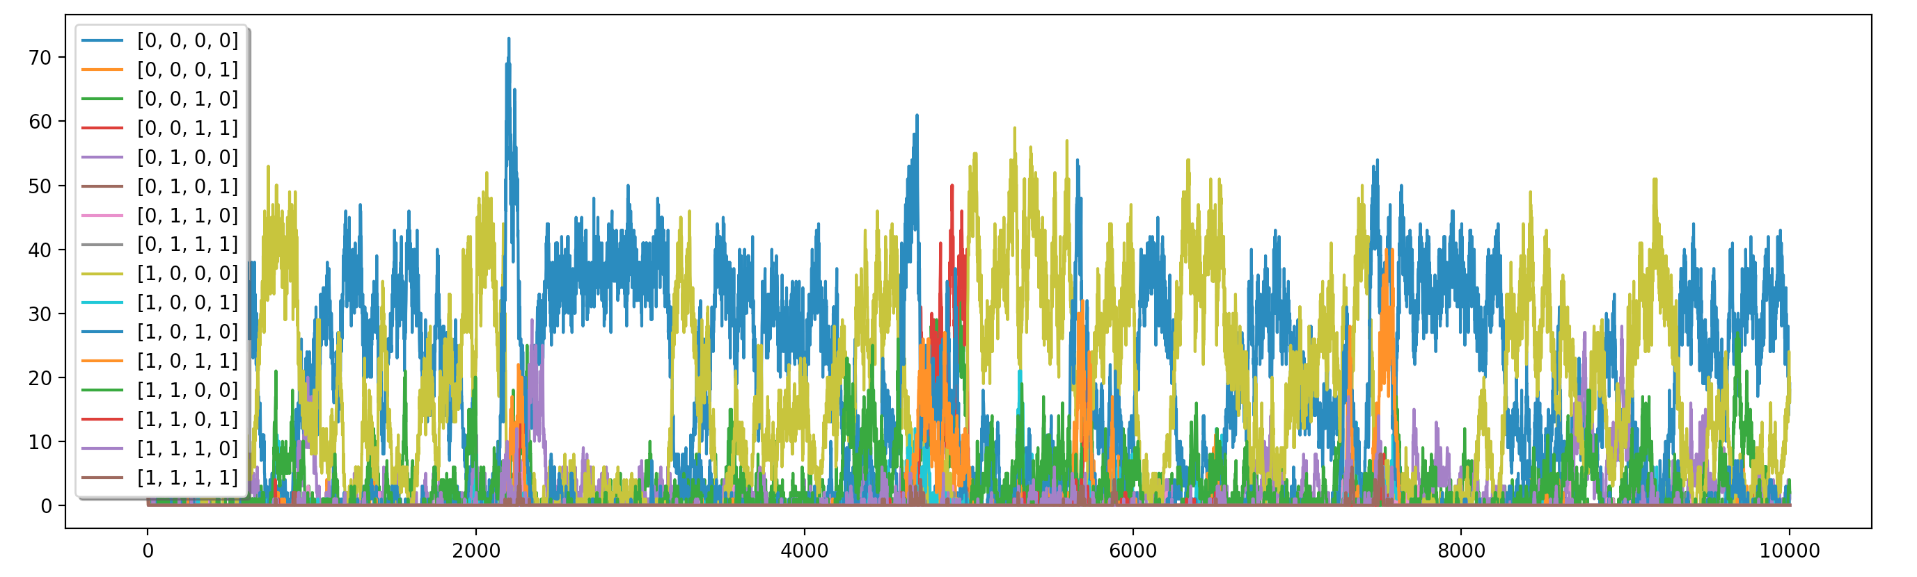

19 0 2 0 1 0 0 0 18 0 0 0 2 0 0 0

**Till now repro till 0, now repro till 1 day consumption left.**

4 Strategy Parmeters #(How to respond to given my last and op last – [cc,cd,dc,dd])

All mutation at a time: N(0,0.1)

All Closest

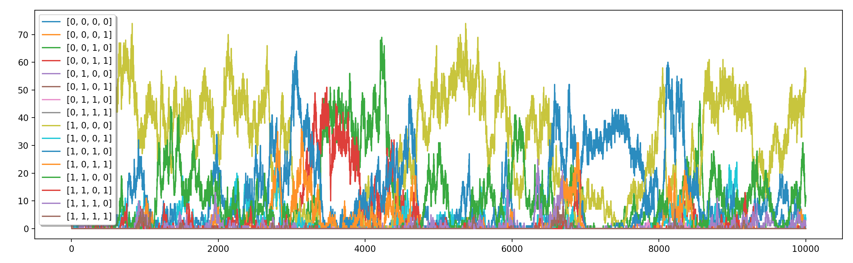

0 0 0 0 0 0 0 0 53 3 1 0 10 1 1 0

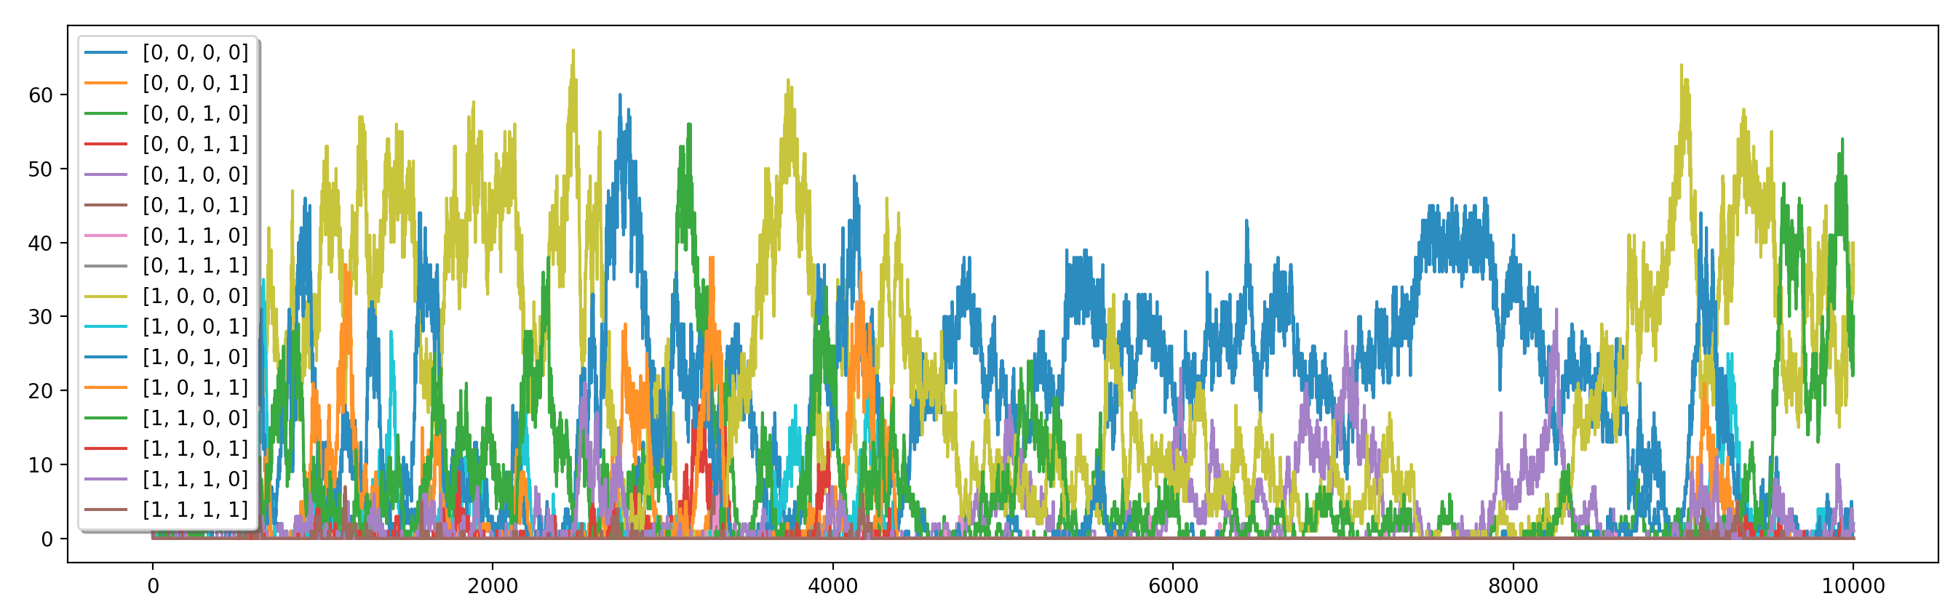

0 0 0 0 0 0 0 0 37 1 2 0 30 0 1 0

**Till now repro till 0, now repro till 1 day consumption left.**

4 Strategy Parmeters #(How to respond to given opp last 2 moves – [cc,cd,dc,dd])

All mutation at a time: N(0,0.1)

All Closest

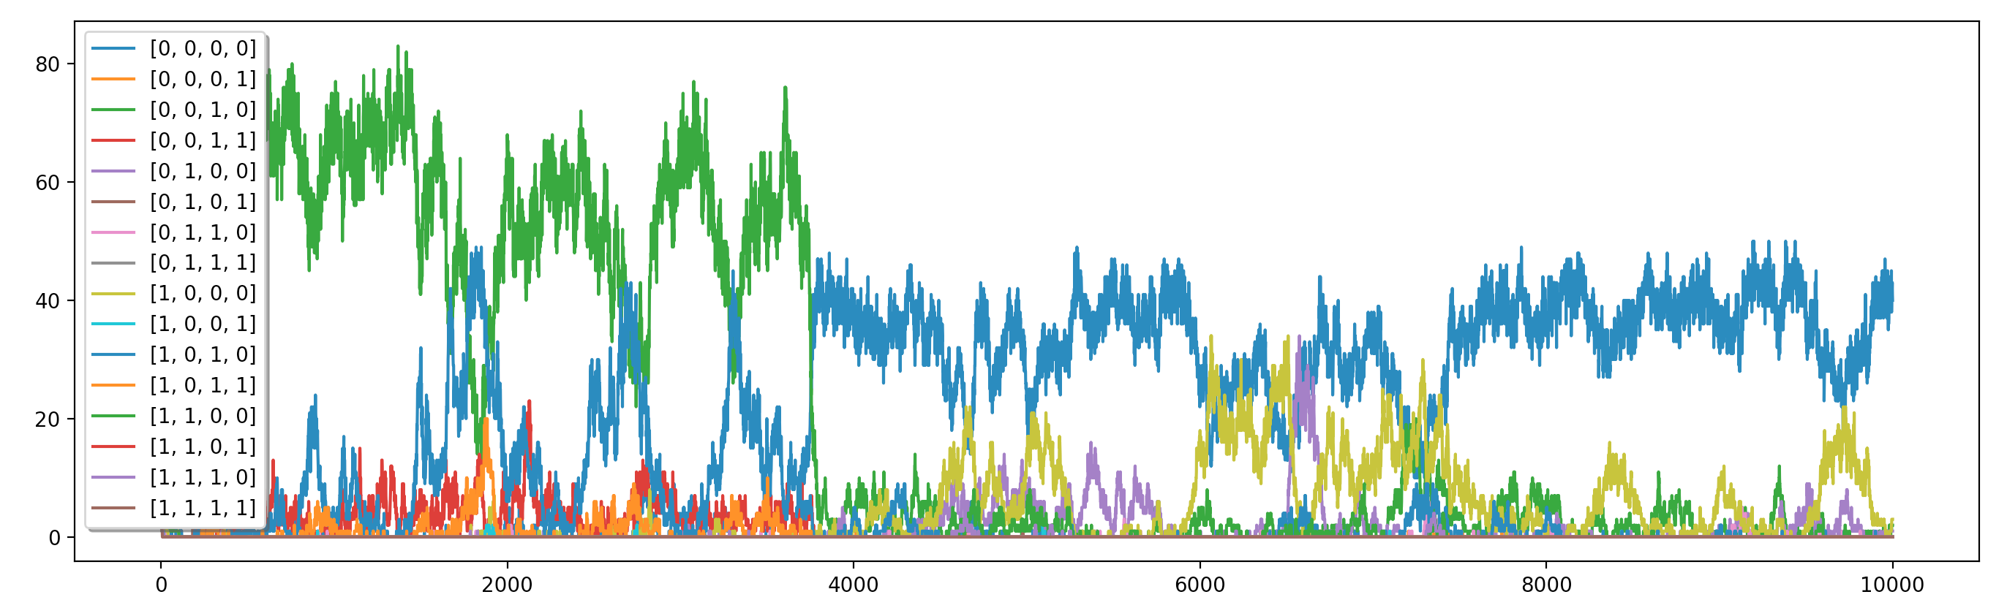

40 0 2 0 1 0 0 0 3 0 0 0 0 0 0 0

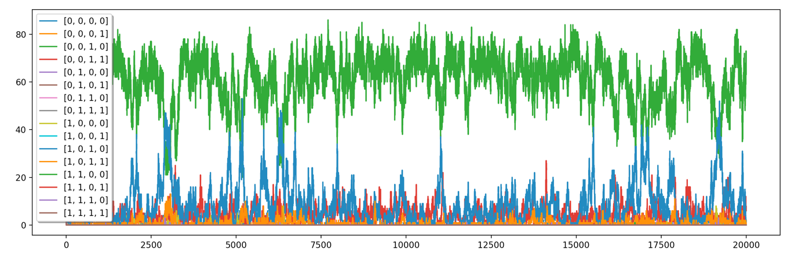

0 0 70 6 0 0 0 0 0 0 2 0 0 0 0 0

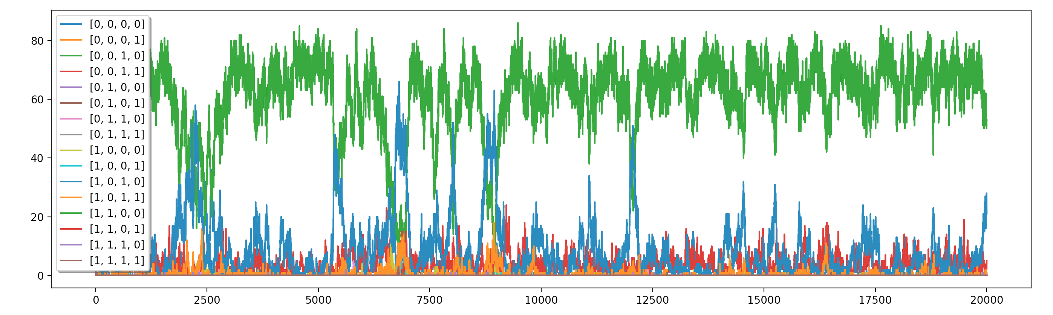

0 0 53 5 0 0 0 0 0 0 21 1 0 0 0 0

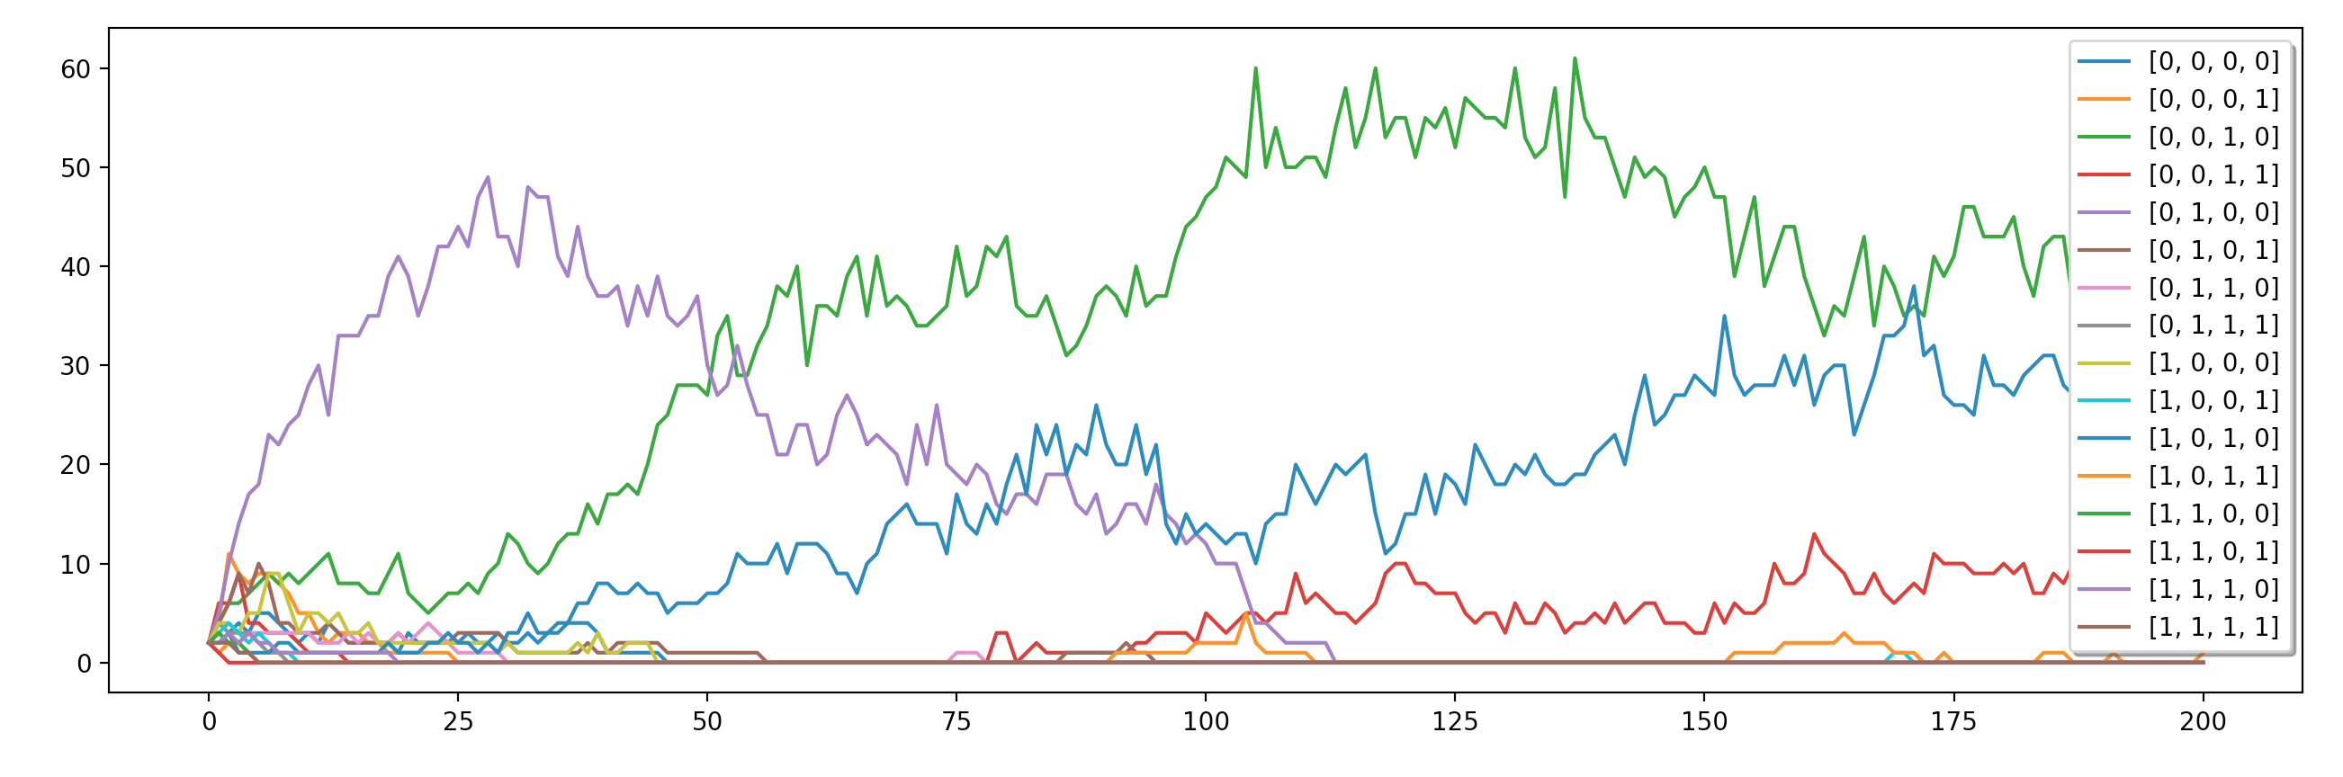

0 0 38 11 0 0 0 0 0 0 37 1 0 0 0 0

